CS 3365 – Software Engineering I

Homework #8

Luis Rausseo – R11478074

Use the following methods trash() to answer the following questions.

1 public void trash (int x)

2 {

3 int m, n;

4 m = 0;

5 if (x > 0)

6 m = 4;

7 if (x > 5)

8 n = 3\*m;

9 else

10 n = 4\*m;

11 int o = takeOut (m, n);

12 System.out.println ("o is: " + o);

13 }

1. Draw the control flow graph for this program, and indicate program statement(s) to the corresponding node or edge on the graph. (5 pts)

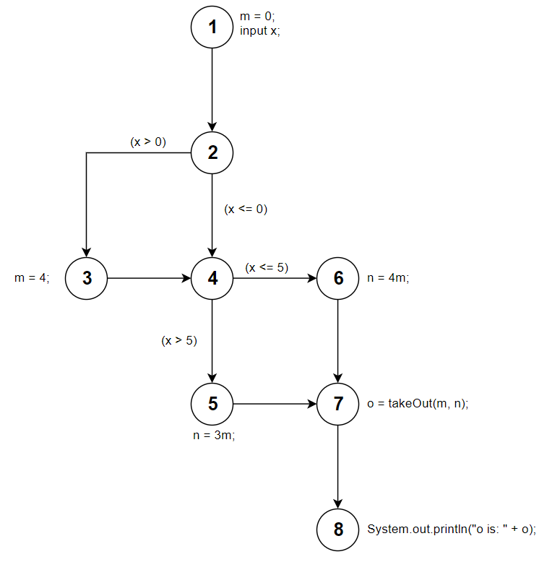

1. Find a minimum number of test paths that satisfies the edge coverage. (5 pts)

*P1 = (1, 2, 3, 4, 5, 7, 8)*

*P2 = (1, 2, 4 ,6 ,7, 8)*

1. Find a set of test data that corresponds to test paths found in (2). (5 pts)

*P1: t1 = (x = -1)*

*P2: t2 = (x = 6)*